CLOUD COMPUTING
LAB 08



Submitted To:
Engr. Shoaib

Submitted By:
Komal Kashif
BSE V-A
2023-BSE-031

Task 1 — Create an AWS account and enable UAE
Steps
- Open your browser and go to: AWS Signup
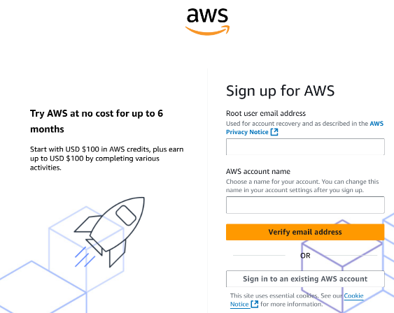
- Complete registration (Account type: Personal, Plan: AWS Paid Plan), fill contact, billing (credit card) and phone details, complete verification
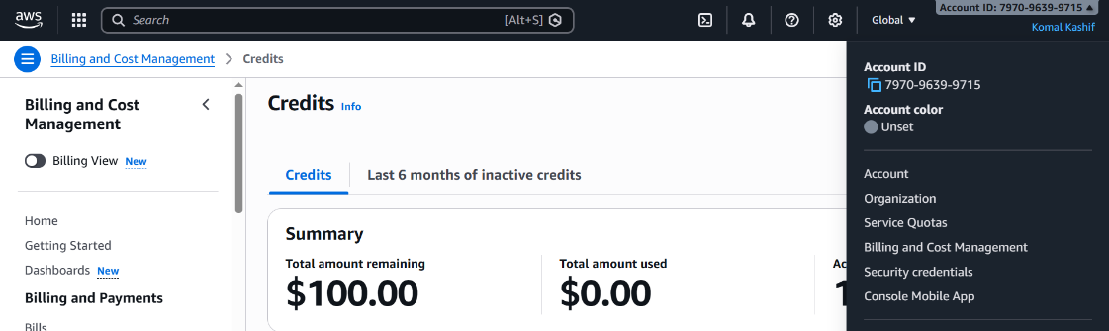
- Sign in as the root user (root email).
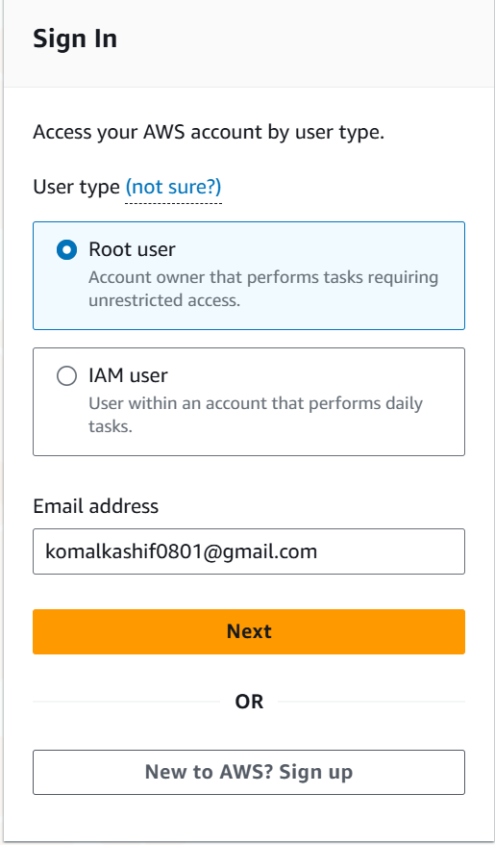
- From the Console, open the region selector and enable UAE (me-central-1), then switch to me-central-1.
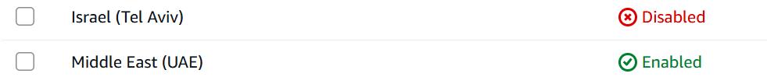
- Task 1 summary screenshot:

Task 2 — Create IAM Admin and Lab8User with console access
Steps
- Open IAM via Console search (Alt+S → "IAM").
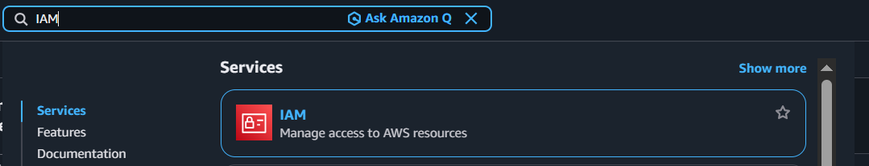
- Create the Admin user: IAM → Users → Create user.
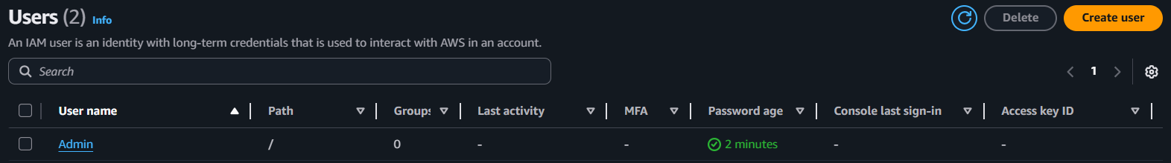
- Download the Admin .csv and show its presence on your Windows host (do not display the password text)
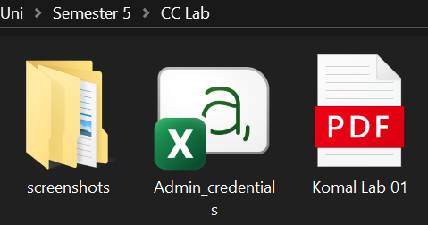
- Sign out of root, then sign in using the Admin account (use the signin URL from the .csv). Capture after successful Admin login:
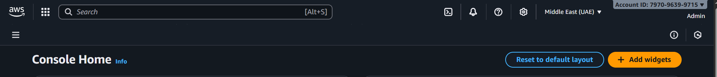
- While logged in as Admin, create Lab8User:
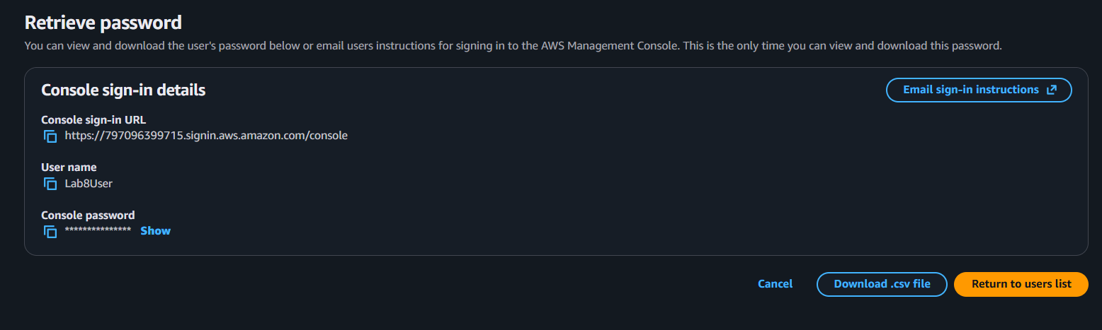
- Download/save the Lab8User CSV on your Windows host (do not show password).
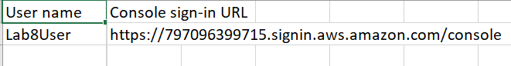
- Logout Admin and login as Lab8User (use the Lab8User signin URL and credentials).
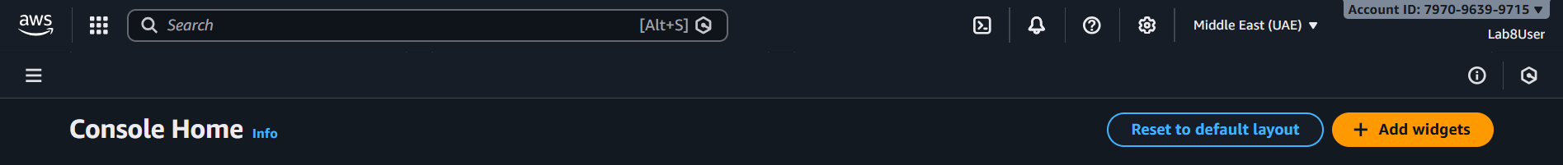
- Task 2 summary
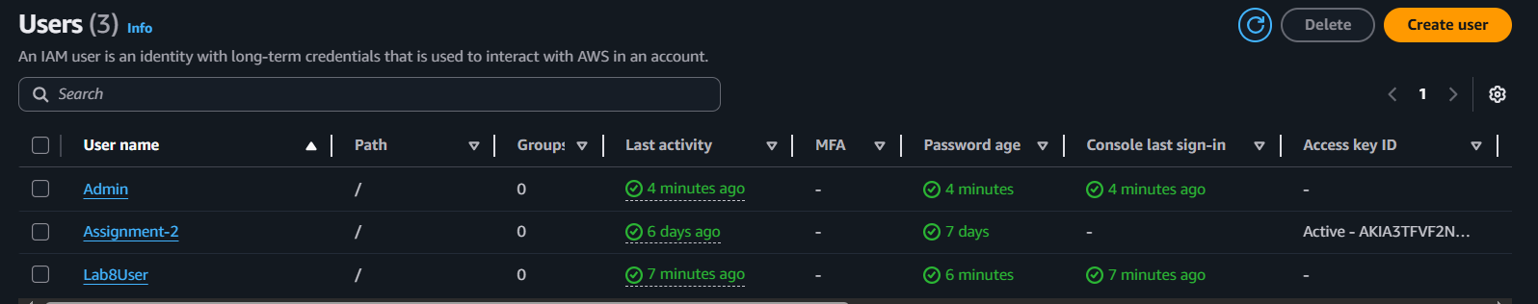

Task 3 — Inspect VPC resources
Steps
- Open VPC console (Alt+S → "VPC") while region is me-central-1.
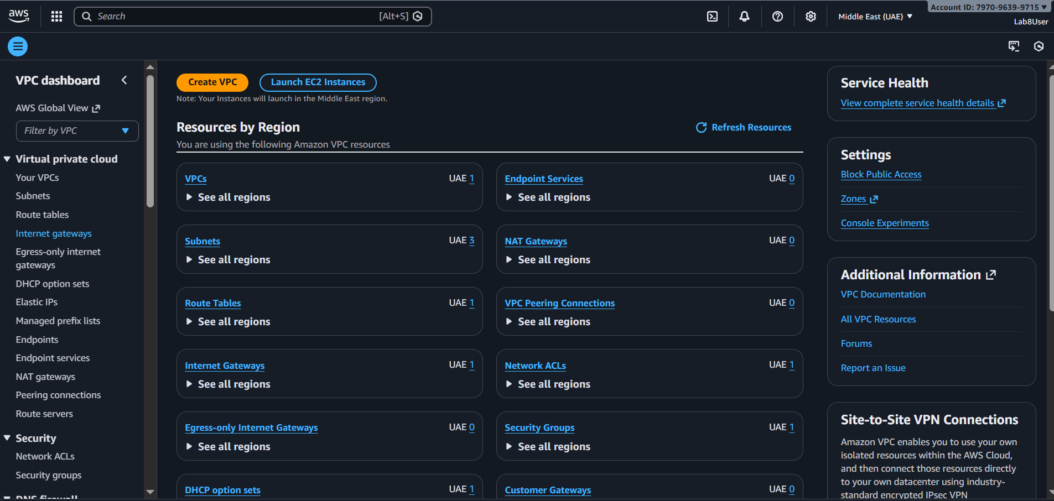
- View VPCs list.
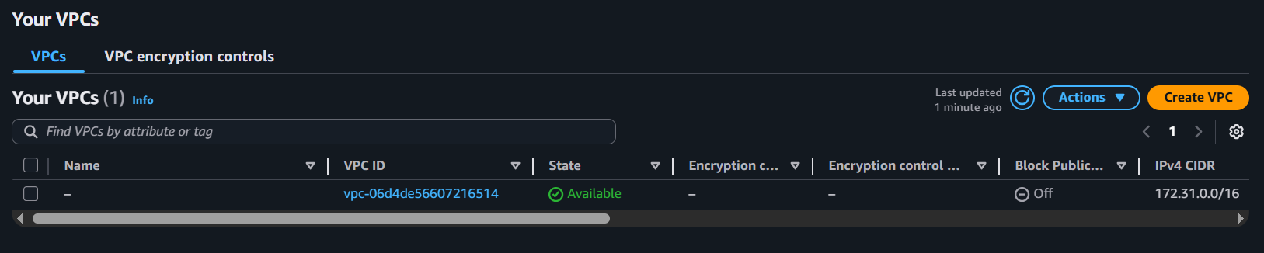
- View Subnets list.
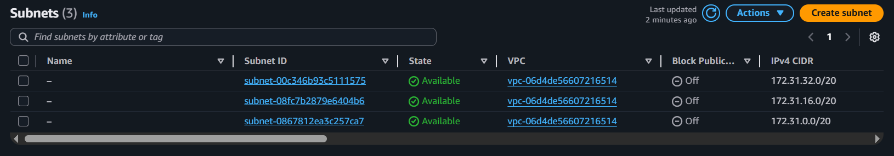
- View Route Tables list.
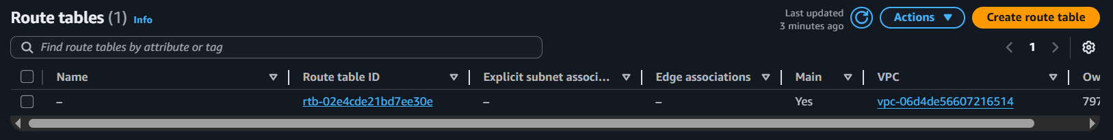

- View Network ACLs list.
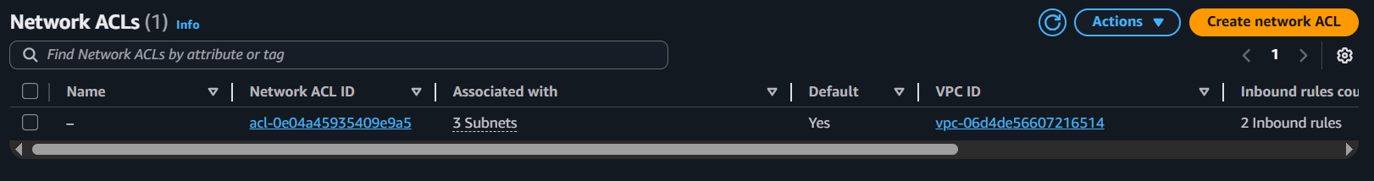
- Task 3 summary
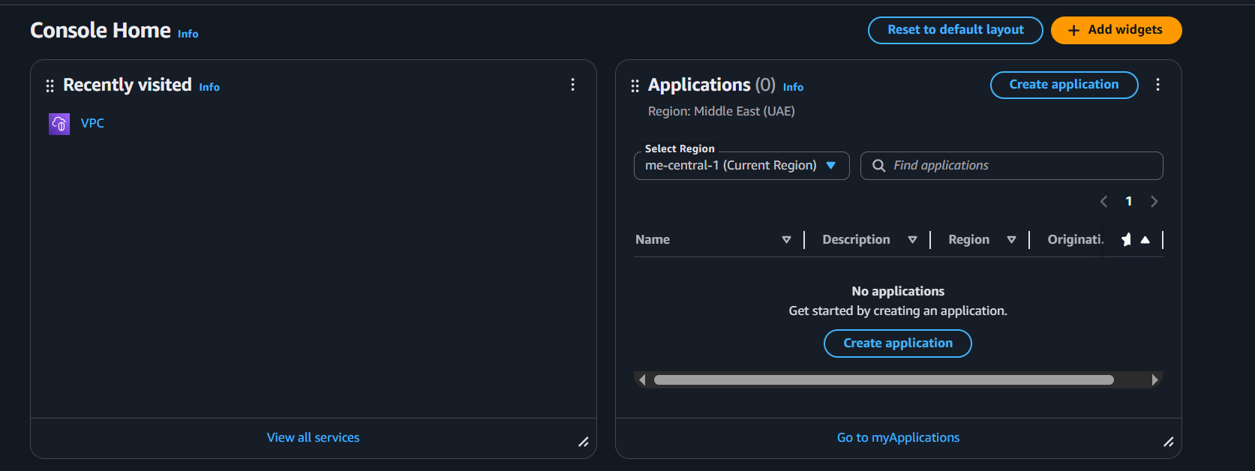

Task 4 — Launch EC2, SSH, install Docker & Docker Compose, deploy Gitea
Steps
- Open EC2 Console (Alt+S → "EC2") (me-central-1).
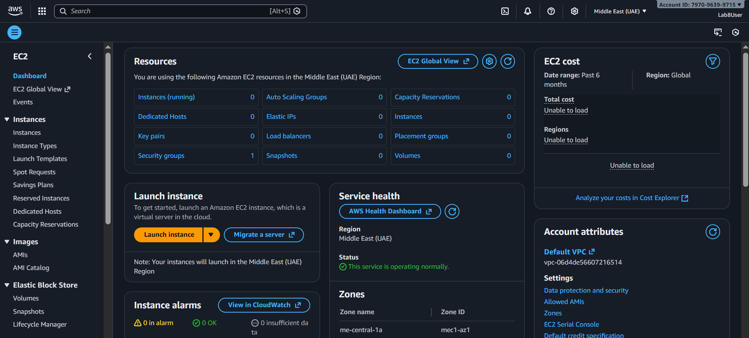

- Instance Launch configuration (during review before launching).
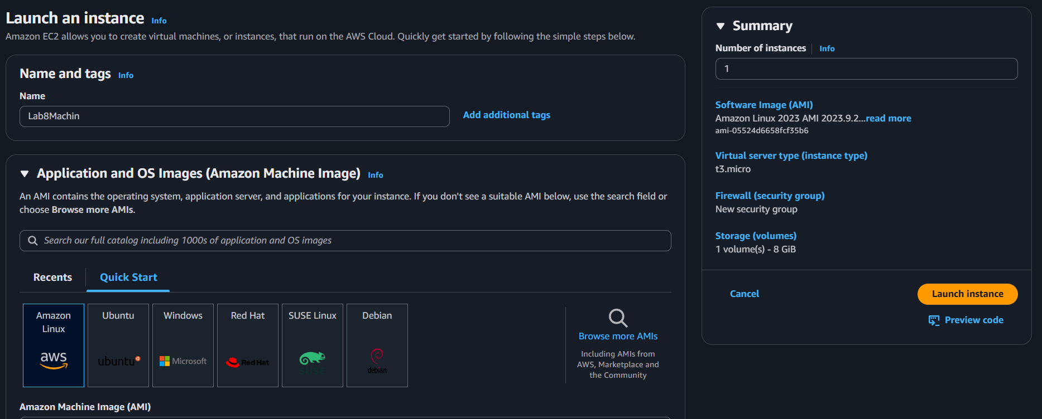
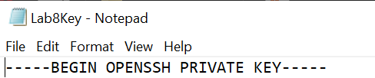
- After launch, EC2 Instances list showing Lab8Machine in "running" state and public IPv4 visible.
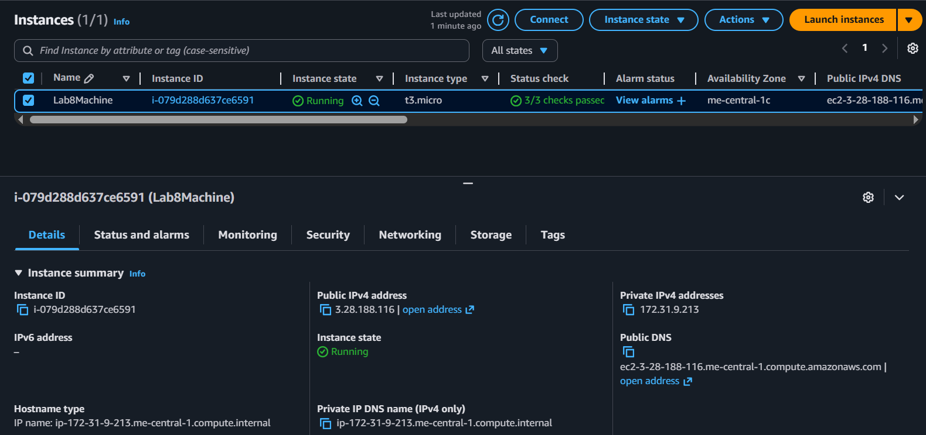

- On Windows host, run SSH using the downloaded .pem (PowerShell/Git Bash/Windows Terminal):
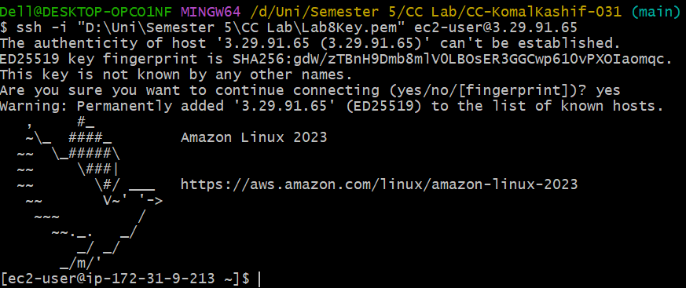
- Run the docker install commands on the EC2 shell:
sudo yum update -y
sudo yum install -y docker
sudo mkdir -p /usr/local/lib/docker/cli-plugins
sudo curl -SL https://github.com/docker/compose/releases/latest/download/docker-compose-linux-x86_64 -o /usr/local/lib/docker/cli-plugins/docker-compose
sudo chmod +x /usr/local/lib/docker/cli-plugins/docker-compose
sudo systemctl start docker
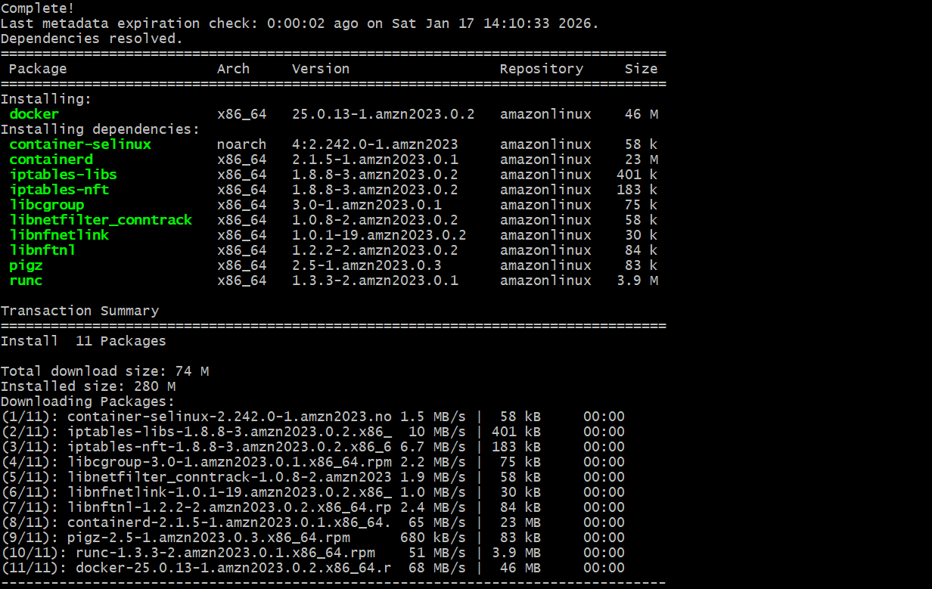

- Create/edit compose.yaml on the EC2 instance (sudo vim compose.yaml) and paste content from the repo: Gitea . While pasting, capture the editor content:
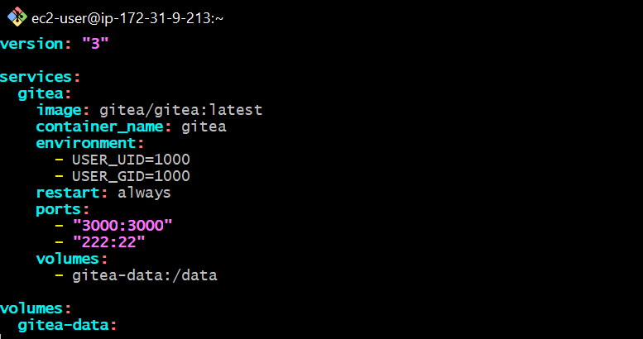
- Save and verify file exists:
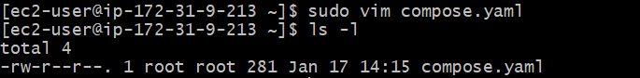
- Add ec2-user to docker group, show groups before re-login, exit and reconnect, show groups after reconnect:
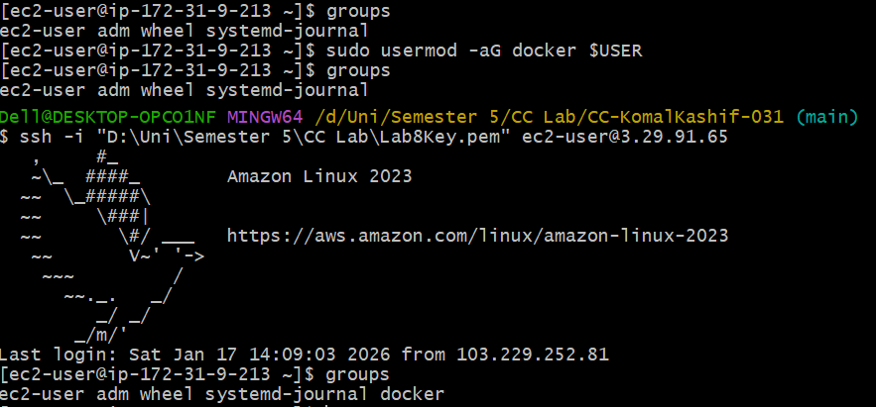
- Run docker compose up -d from the directory with compose.yaml:
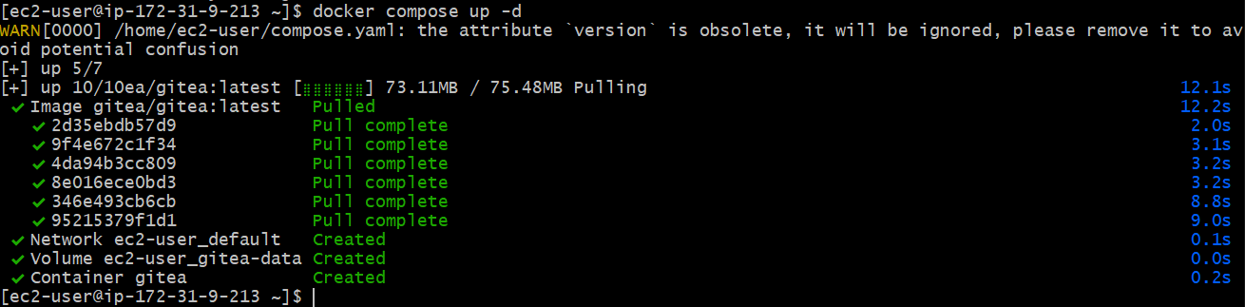

- Edit the security group Lab8SecurityGroup inbound rules in the EC2 console: add Custom TCP rule port 3000 source 0.0.0.0/0 and save. Capture the inbound rules after saving:
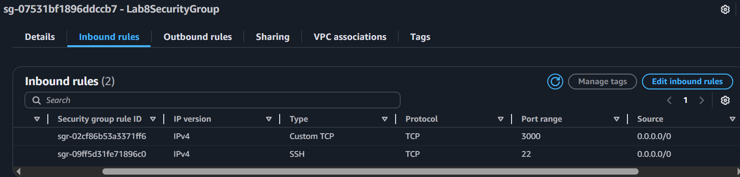
- From your Windows browser navigate to: http://Public-IP:3000 — capture the Gitea setup/install page:
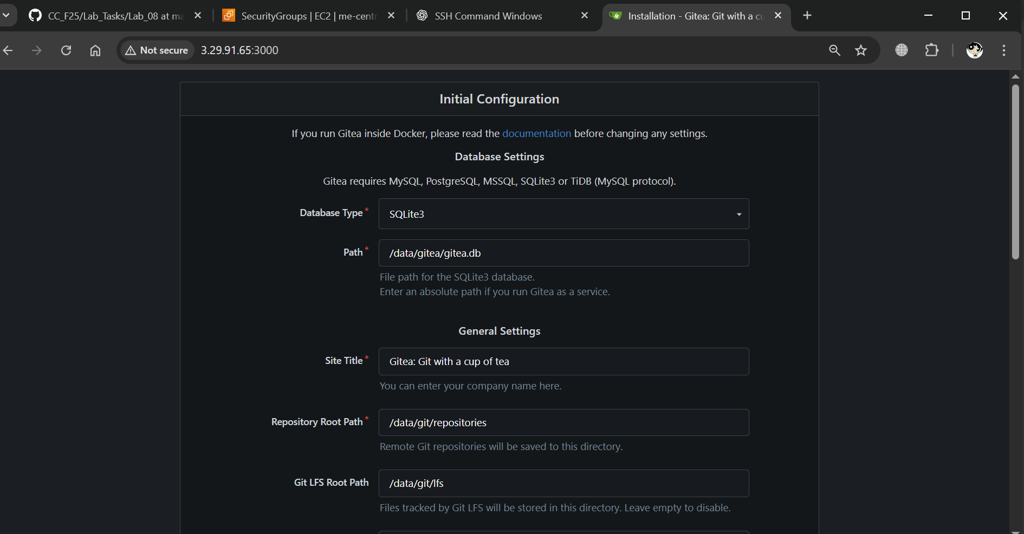
- Complete initial Gitea setup (create admin user, create a repo) and capture Gitea showing the created repository:
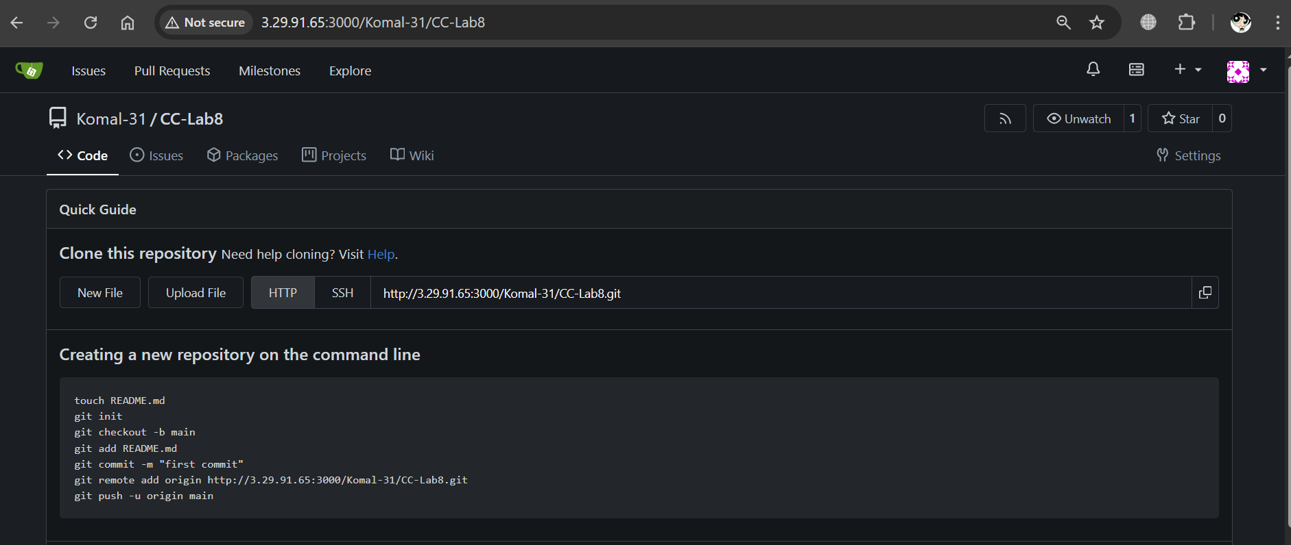
- Task 4 summary
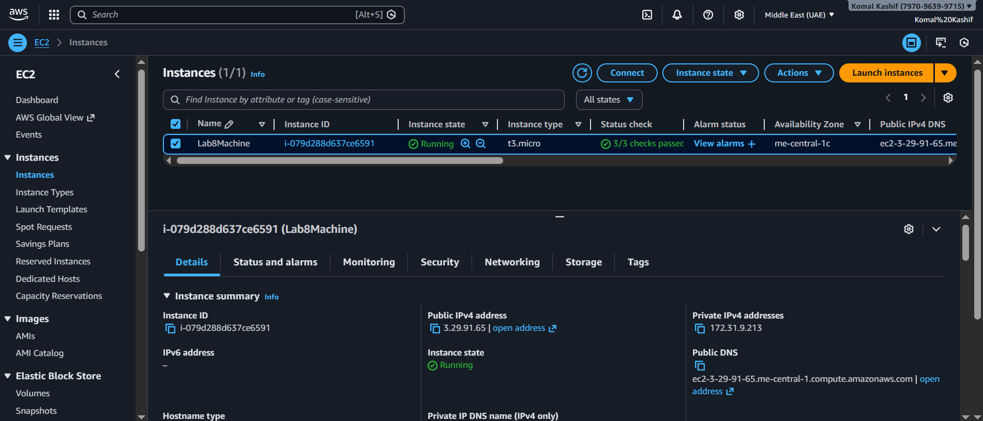

Cleanup — Remove resources to avoid charges
- Terminate the EC2 instance Lab8Machine.
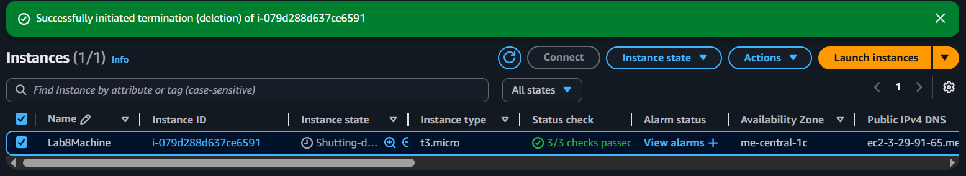
- Delete associated EBS volumes and snapshots
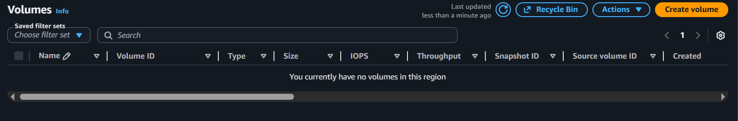
- Delete security group Lab8SecurityGroup and key pair Lab8Key from the EC2 console
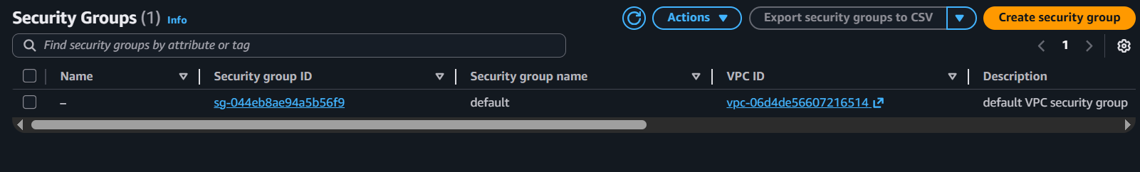

- Delete IAM users Lab8User and any access keys.
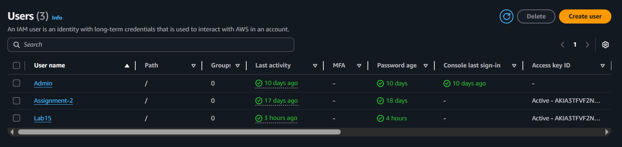
- Final cleanup summary
